# BANNARI AMMAN INSTITUTE OF TECHNOLOGY

**An Autonomous Institution Affiliated to Anna University - Chennai, Accredited by NAAC with A+ Grade**

**Sathyamangalam - 638401 Erode District, Tamil Nadu, India**

|  |  |
| --- | --- |
| **Name** | **JOGINADH R** |
| **Roll number** | **7376222CT120** |
| **Project number** | **26** |
| **Problem statement** | **RP REDEMPTION AUTOMATION** |
| **Seat Number** | **338** |

# PROBLEM STATEMENT:

The current manual process of redeeming reward points at [Your Institution Name] is inefficient, error-prone, and time-consuming, leading to administrative burdens and student dissatisfaction. Users face significant delays and inefficiencies in tracking points, submitting redemption requests, and receiving timely approvals, while administrators struggle with managing and processing numerous requests, resulting in errors and inconsistent handling. "Rewards Points Redemption Automation" aims to streamline this process by developing an automated system that leverages a robust DBMS for efficient data management. This system will handle tasks such as setting redemption dates, sending detailed emails to students, processing point conversions, and confirming redemptions. It will provide secure user authentication, streamlined points management, an intuitive dashboard, automated approval workflows, and comprehensive report generation. By automating these steps, the project seeks to improve efficiency, accuracy, and communication, ultimately enhancing the overall student experience and reducing the workload on administrative staff.

# STACK:

|  |  |
| --- | --- |
| **Component** | **Tech Stack** |
| Frontend | Angular (Js Framework) |
| Backend | Node.js(Javascript runtime environment) Express.js(Web Framework for Node.js) |
| Database | MongoDB(NOSQL Database) |
| API | REST Ful API / GraphQL APIs |

**PROGRESS - TIMELINE:**

|  |  |  |  |
| --- | --- | --- | --- |
| Phase | Deadline | Status | Notes |
| Stage 1 | 23/07/2024 | **In Progress** | Planning and Requirement Gathering |
| Stage 2 |  | **Not Started** | Design and Prototyping |
| Stage 3 |  | **Not Started** | DB Designing |
| Stage 4 |  | **Not Started** | Backend Implementation |
| Stage 5 |  | **Not Started** | Testing & Implementation |
| Stage 6 |  | **Not Started** | Deployment |

# PROJECT OVERVIEW:

1. Purpose:

To create a website for automating the rewards points redemption process, aimed at streamlining the user experience and improving efficiency in managing and redeeming rewards points.

1. Scope:

This system will encompass user authentication, rewards management, points tracking, redemption workflow, and report generation functionalities. It aims to simplify the process of tracking and redeeming rewards points for both users and administrators.

1. Dependencies:
   * + Integration with the organization's email system for user authentication.
     + Availability of internet connectivity for system access.
2. Database Management System (DBMS);

A DBMS is essential in this project to efficiently manage and store large volumes of reward points data, ensure secure user authentication, streamline points tracking and management, automate approval workflows, and generate comprehensive reports. This enhances data integrity, operational efficiency, and accurate, timely redemptions.

1. User Personas:
   * + Admin: Responsible for managing rewards, redemption requests, and approvals.
     + Student/User: Submits redemption requests, monitors points balance, and redemption status

# FUNCTIONAL REQUIREMENTS:

## 1.User Authentication

* + - Description: Users should be able to securely log in using their organization mail IDs.

#### Features:

* + - * Secure authentication mechanism using organization mail IDs.
      * Password protection to ensure user account security.
      * Forgot password functionality for password recovery.

## 2.Rewards Points Management

* + - Description: Users and admins should be able to manage and track rewards points.

#### Features:

* + - * Display of current points balance for each user.

## 3.Home Page

* + - Description: Dashboard for users and admins.

#### Features:

* + - * User/Admin Dashboard with a summary of rewards points.
      * Display of available rewards categorized by type and points required.

## 4.Redemption Report Creation

* + - Description: Users and admins can generate detailed reports on redemption activities.

#### Features:

* + - * Date of redemption.
      * Points spent.
      * Description of the redeemed reward

## 5.Approval Workflow

* + - Description: Reviewers can approve and review reports, provide clear remarks for disapproval, and allow users to re-edit specific sections.
    - Features:
      * Clear status indicators for pending, approved, or rejected reports.
      * System tracks the number of edits and reviews for each report.
      * Notifications sent to users for any required edits or final approval.

## 6.Report Generation

* + - Description: Once approved, reports are downloadable in PDF format (max 2MB).
    - Features:
      * Detailed summary of redemption activities.
      * Points balance and transaction history.
      * Users are notified of report availability for download.

# Strategies To Enhance Workflow:

# To enhance workflow for this project, we will implement several strategies.

# First, we will automate routine tasks such as point tracking, redemption requests, and approval processes, reducing manual effort and minimizing errors.

# Utilizing a robust DBMS will ensure efficient data management and secure user authentication. An intuitive dashboard will provide real-time updates and easy access to relevant information for both administrators and students.

# Automated notifications and detailed emails will improve communication and ensure timely responses.

# Additionally, we will incorporate comprehensive report generation to monitor and analyze the system’s performance, enabling continuous improvement. These strategies will collectively enhance efficiency, accuracy, and user satisfaction

**ER DIAGRAM:**

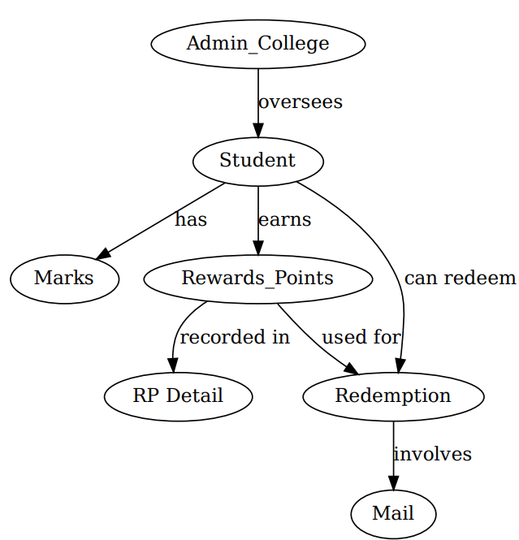

**FLOWCHART:**

Student’s Dashboard

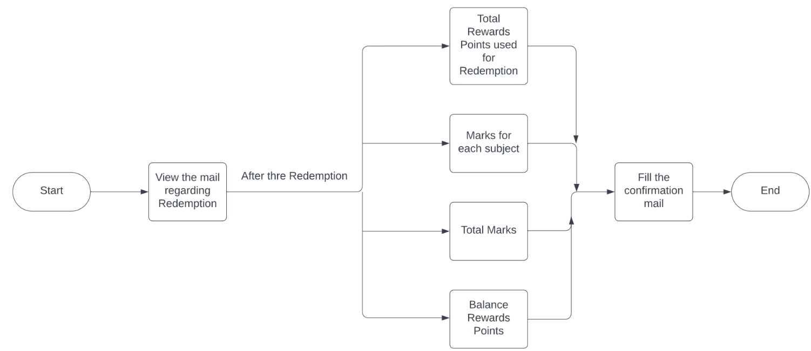

Admin’s Dashboard

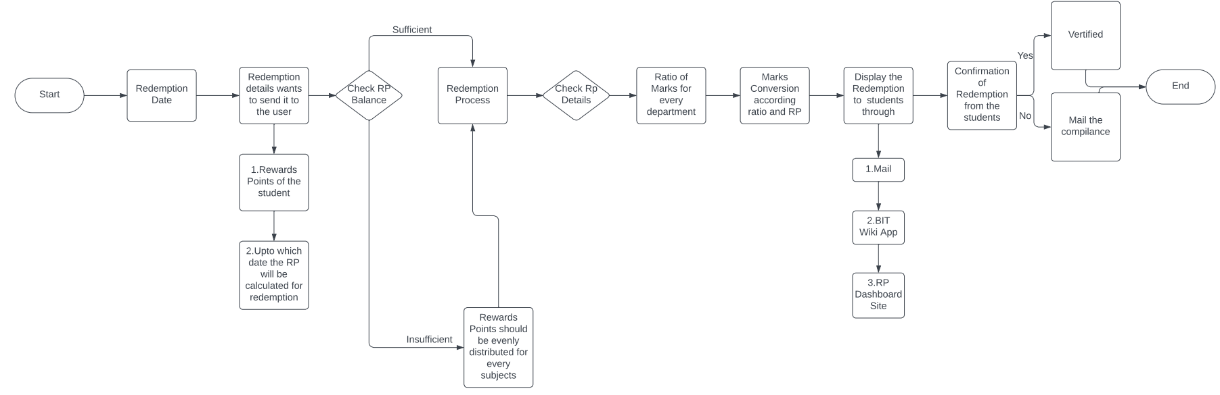

**ER DIAGRAM**

